Meneses, James Joash F.

2-ECE-D

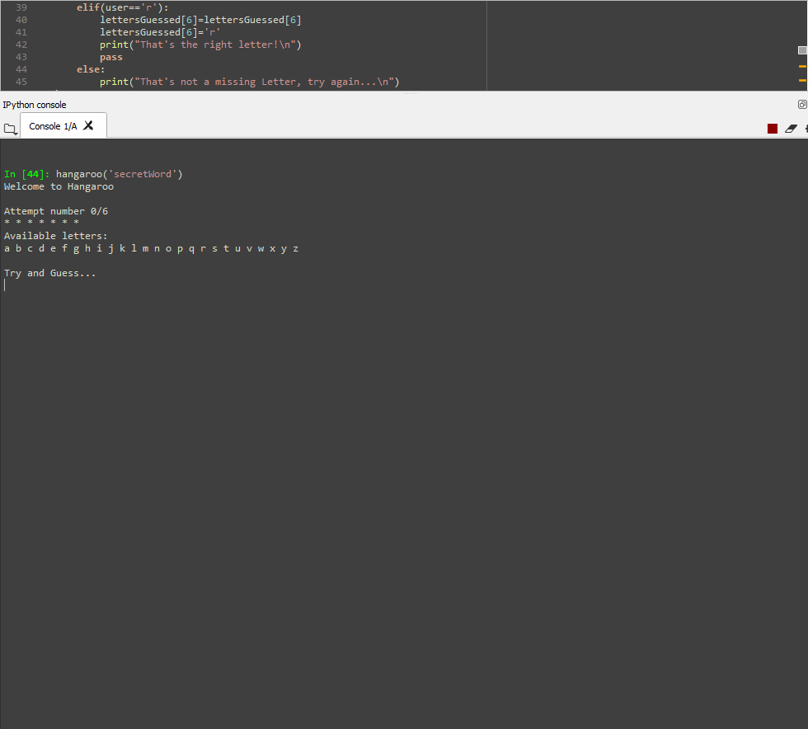

Game Start

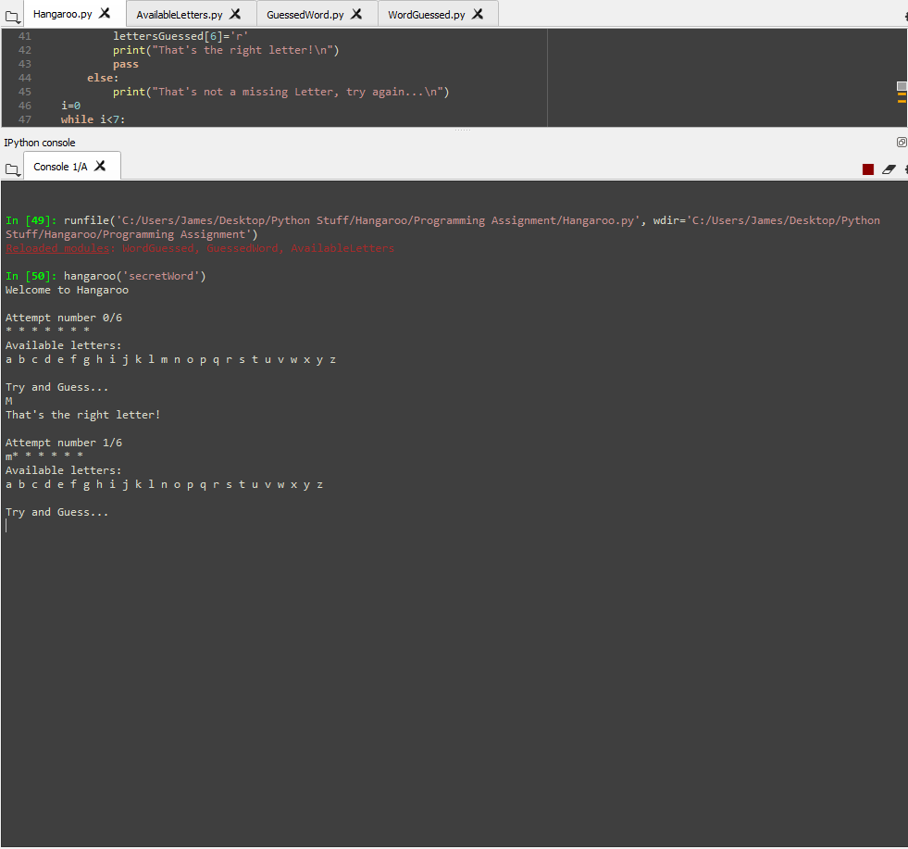

Correct Guess (Uppercase)

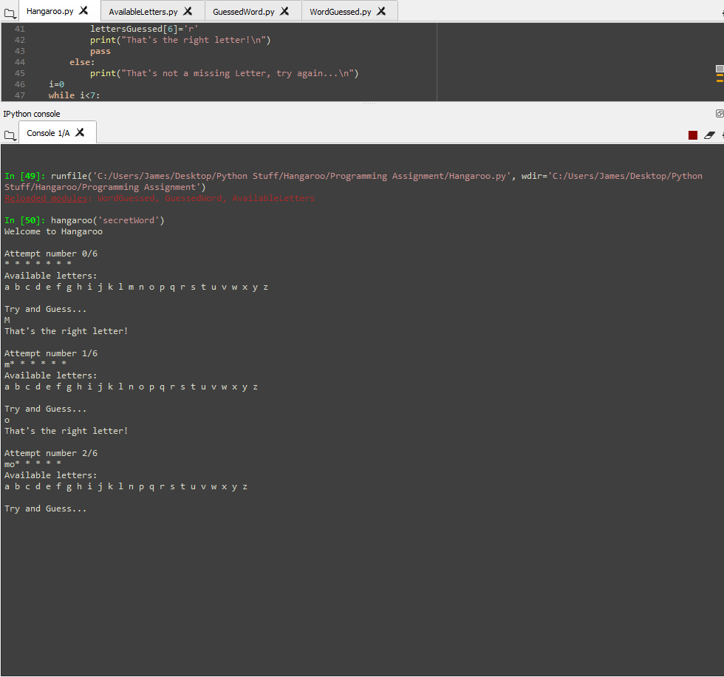

Correct Guess (Lowercase)

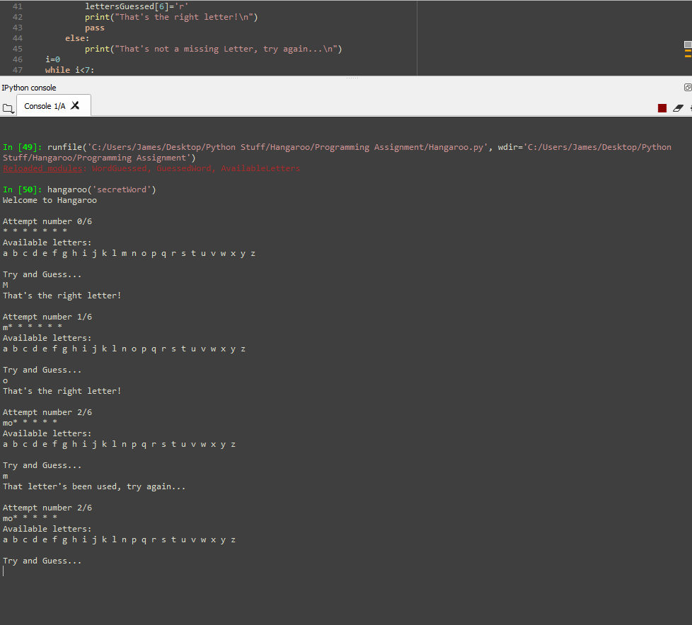

Repeated guesses result in redoing the attempt

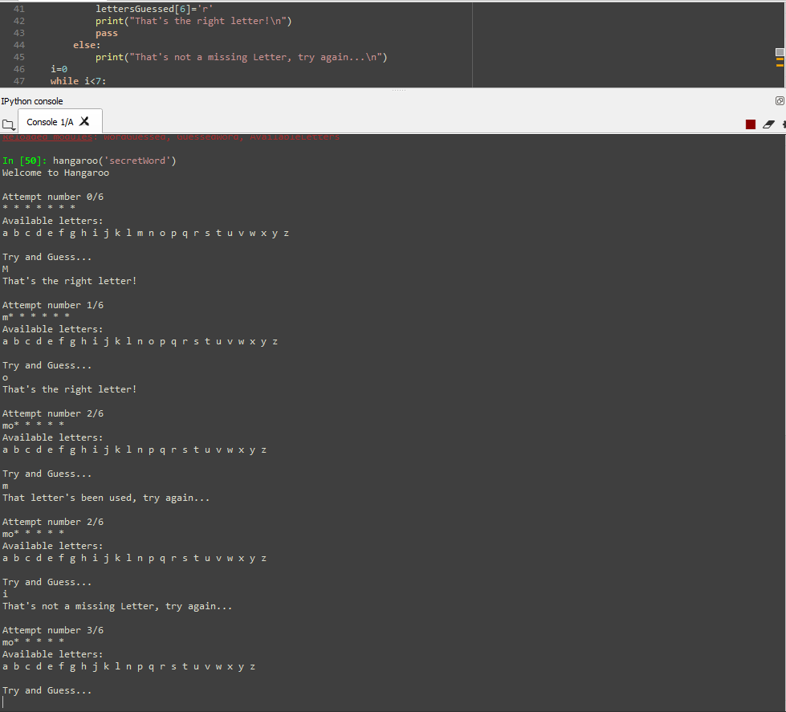

Incorrect Guess

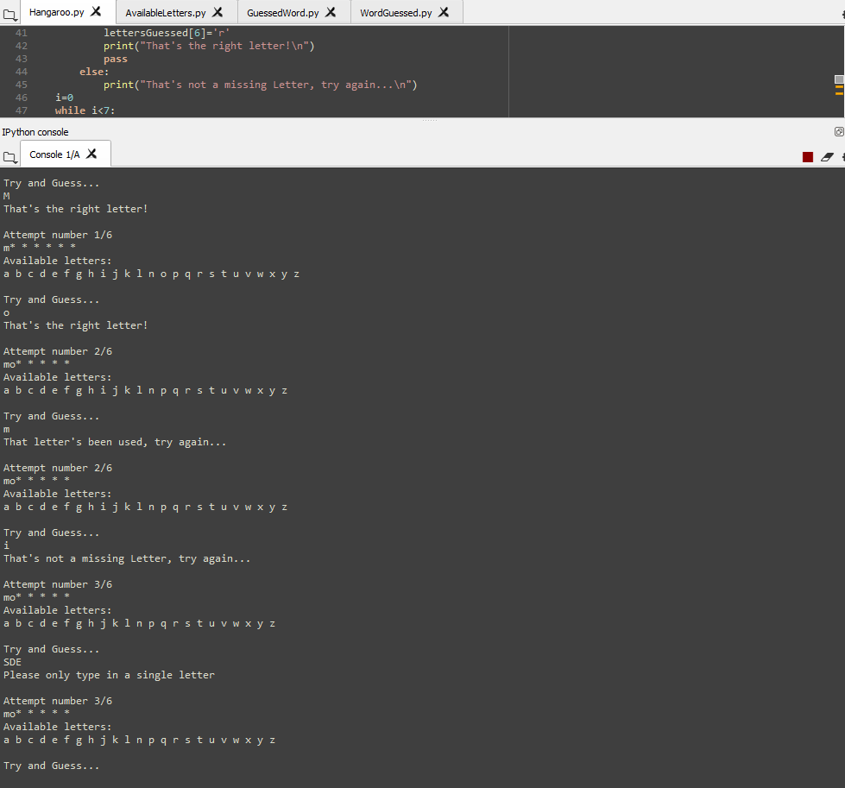

Not only typing either a single uppercase or lowercase letter results in redoing the attempt

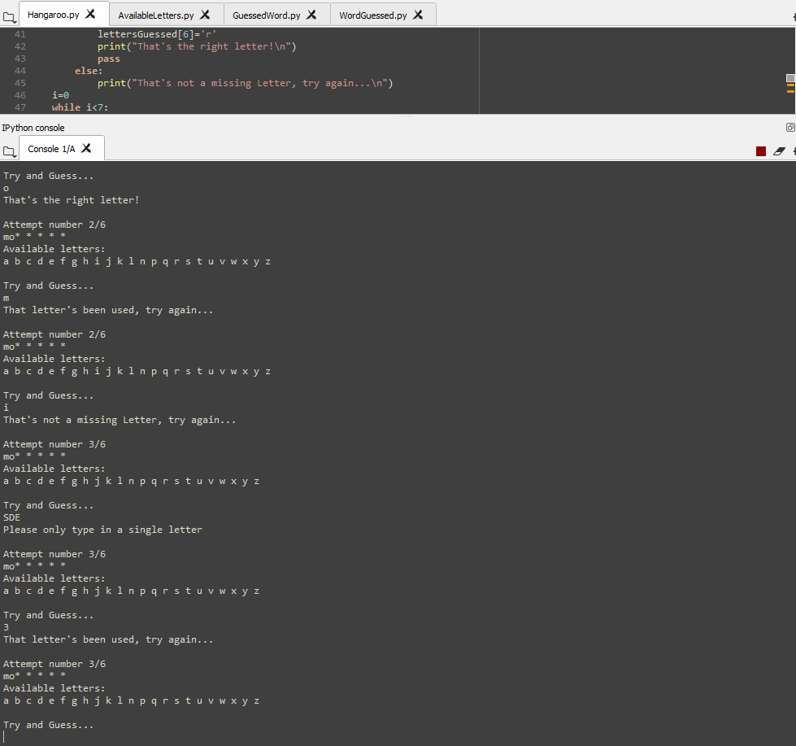

Typing a number results in redoing the attempt

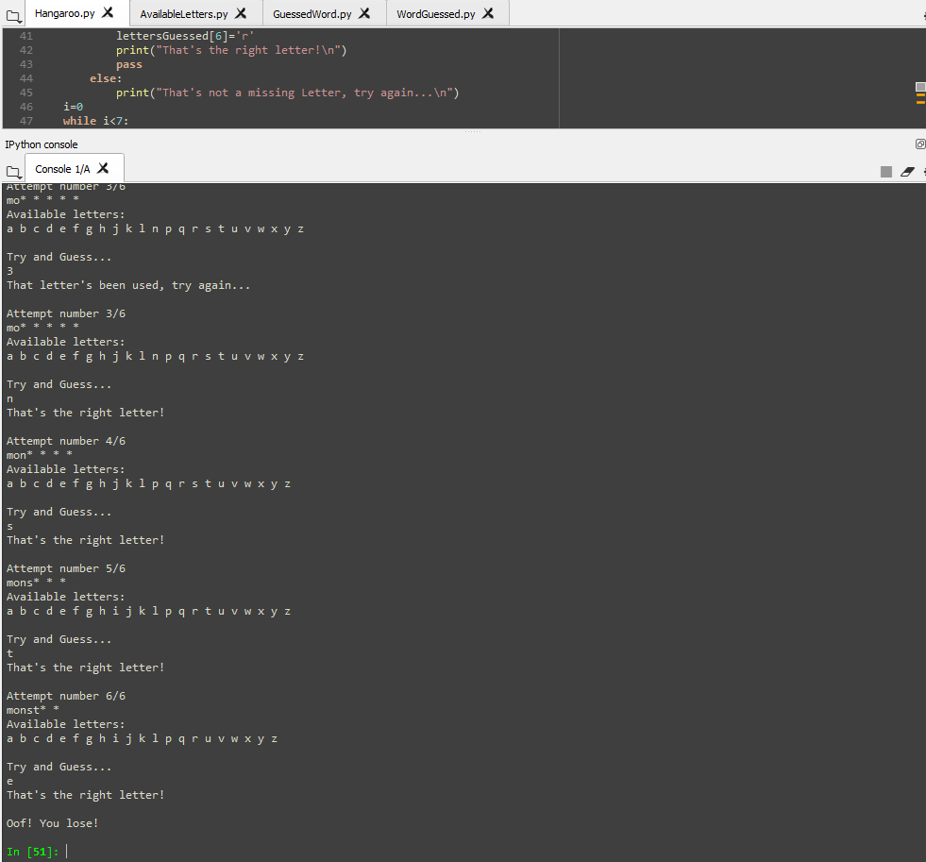

Exceeding number of maximum attempts while not solving the word results in lose condition

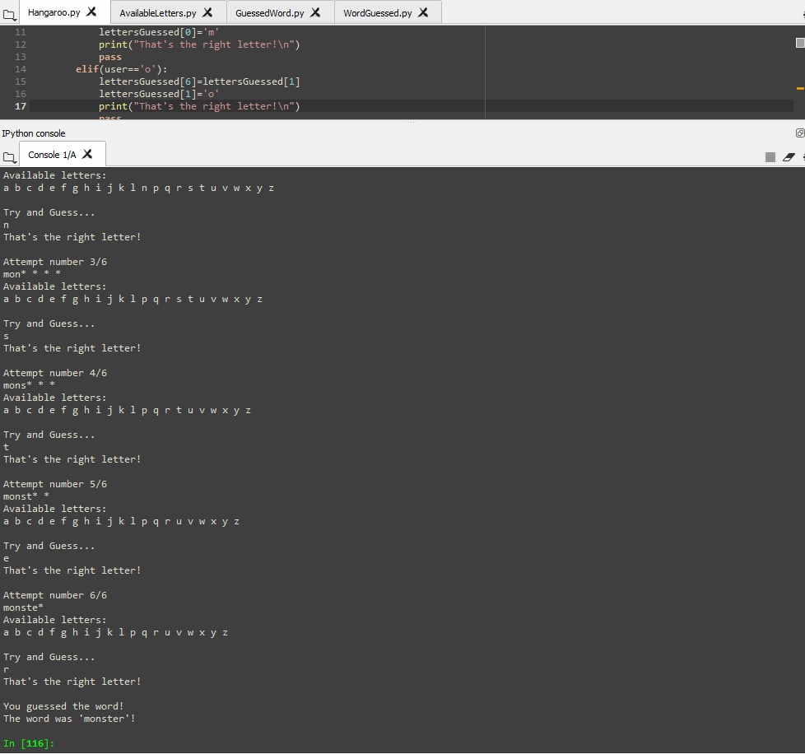

Successfully guessing the word results in the win condition